Healthcare Chatbot for Patient Query Resolution

**MINI PROJECT SYNOPSIS**

***of***

# BACHELOR OF ENGINEERING

***in***

# INFORMATION SCIENCE & ENGINEERING

***by***

|  |  |  |  |
| --- | --- | --- | --- |
| **Shiva Prasad R** | **Sanju A S** | **Rakesh D** | **Darshan G K** |
| **1AK22IS046** | **1AK22IS044** | **1AK22IS036** | **1AK22IS008** |

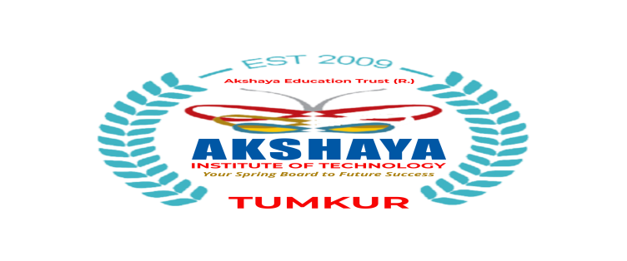

**DEPARTMENT OF INFORMATION SCIENCE & ENGINEERING AKSHAYA INSTITUTE OF TECHNOLOGY**

**(AFFILIATED TO VTU, BELAGAVI)**

**Introduction**

* The "Healthcare Chatbot for Patient Query Resolution" is designed to streamline patient interaction with healthcare providers by automating the process of answering common health-related queries.
* This project leverages Natural Language Processing (NLP) and chatbot technology to provide real-time responses to patient queries about symptoms, medications, doctor availability, and appointment scheduling.
* The chatbot, powered by Flask, interacts with users via a web interface, processes their inputs using NLP techniques, and fetches appropriate responses.
* The chatbot serves as an intermediary between patients and healthcare professionals, improving efficiency and reducing the need for human interaction in non-emergency situations.
* Additionally, it stores patient interactions in a database, offering personalized responses based on patient history.
* The project utilizes Flask for the backend, HTML/CSS for the frontend, and a SQLite database for storing user queries.
* The use of Python libraries such as NLTK for NLP ensures that the chatbot can understand and process user queries more accurately.
* This project is applicable in the healthcare field, particularly in improving patient communication and assisting healthcare providers in offering a seamless experience.
* Terms like Natural Language Processing, Flask Framework, and Database Management are central to the understanding of the technical implementation of this project.

**Objective**

The objectives of the project are as follows:

* To provide a chatbot that can handle common healthcare-related queries from patients.
* To assist patients in checking symptoms, scheduling appointments, and retrieving medication information.
* To integrate NLP for better understanding of user inputs and provide accurate responses.
* To maintain a database of user queries and responses to enable personalized healthcare interactions.
* To reduce the workload of healthcare staff by automating frequently asked questions.

**Feasibility Study**

The feasibility study of this project covers technical, operational, and economic aspects:

* Technical Feasibility: The technologies used—Flask, Python, NLP, and HTML are widely available and well-documented, ensuring that the project is feasible in terms of development. The team is familiar with these technologies, minimizing technical risks.
* Operational Feasibility: The chatbot will improve the efficiency of patient query handling by reducing manual work for healthcare providers. It can be easily integrated into existing hospital systems.
* Economic Feasibility: Since the project uses open-source technologies, the cost of development is minimal. Deployment costs may include hosting, which is manageable within a limited budget.

The project is significant as it enhances patient engagement, optimizes the workload of healthcare staff, and provides real-time, reliable information to users.

**Methodology/Planning of Work**

The methodology to be followed for the development of the project includes the following steps:

1. Requirement Analysis: Gather requirements for the types of queries to be handled by the chatbot and identify the necessary data sources.
2. Design and Development: Design the chatbot interface, develop the Flask backend, and implement NLP for processing patient queries.
3. Database Setup: Set up the database to store patient details, queries, and previous interactions.
4. NLP Integration: Integrate Natural Language Processing to improve the chatbot's ability to understand and respond to queries.

1. Testing: Test the chatbot with sample data to ensure accurate responses and user satisfaction.
2. Deployment: Deploy the chatbot on a web server for accessibility and integrate it with healthcare systems if necessary.

**Application-Based Project**

**a) Software/Hardware Requirements**

**Software:**

* Python 3.x
* Flask Framework
* NLTK Library for NLP
* SQLite Database
* HTML, CSS, JavaScript for frontend development

**Hardware:**

* Standard development machine with internet access for testing and deployment.

**b) Benefits of the Project for Society**

* This project is designed to improve healthcare accessibility by providing patients with a reliable tool to get answers to common health-related questions.
* It enhances patient engagement, reduces the need for human interaction in non-emergency cases, and provides real-time responses, thus saving time for both patients and healthcare professionals.
* It can be especially beneficial in remote areas where immediate access to healthcare providers is limited.

**Bibliography**

1. Flask Documentation: Flask Web Development Guide - Flask Documentation.
2. Natural Language Toolkit (NLTK): NLTK Documentation - For implementing NLP features in the chatbot.
3. SQLite Documentation: SQLite Database Management - Official SQLite Documentation.
4. Rasa Documentation: Guide on advanced chatbot development using Rasa for future expansion of the project.